Install On-premises Data Gateway
Download and install a standard gateway
Because the gateway runs on the computer that you install it on, be sure to install it on a computer that's always turned on. For better performance and reliability, we recommend that the computer is on a wired network rather than a wireless one.
- Download the standard gateway.
- In the gateway installer, keep the default installation path, accept the terms of use, and then select Install.
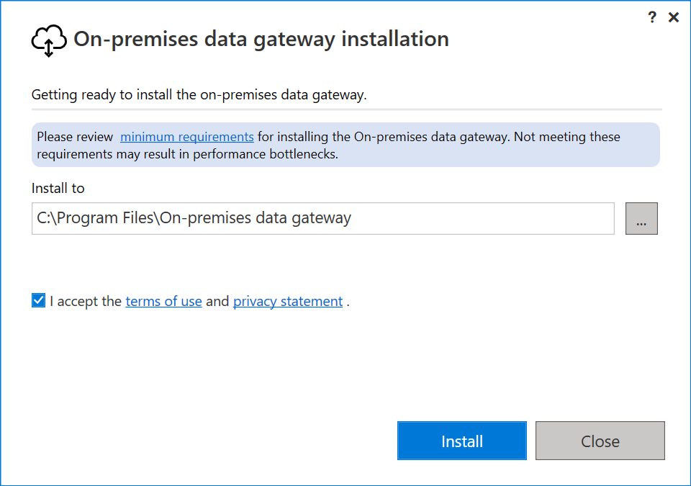
- Enter the email address for your Office 365 organization account, and then select Sign in.
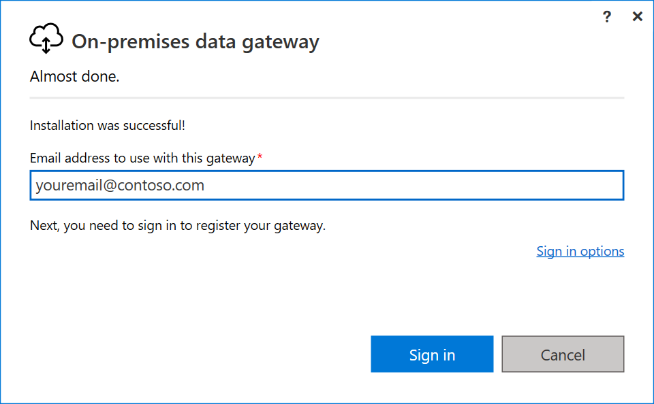
Note
You need to sign in with either a work account or a school account. This account is an organization account. If you signed up for an Office 365 offering and didn't supply your work email address, your address might look like nancy@contoso.onmicrosoft.com. Your account is stored within a tenant in Microsoft Entra ID. In most cases, your Microsoft Entra ID account's User Principal Name (UPN) matches the email address.
- The gateway is associated with your Office 365 organization account. You manage gateways from within the associated service.
You're now signed in to your account.
- Select Register a new gateway on this computer > Next.
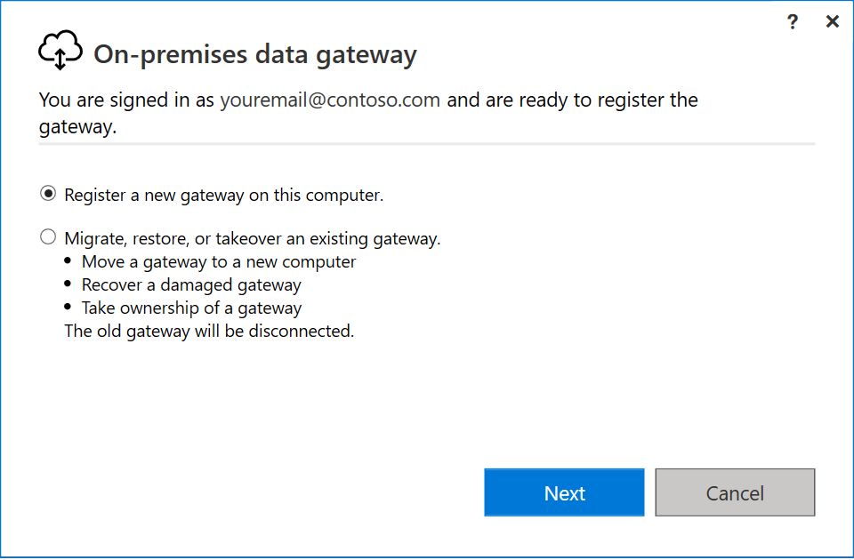
- Enter a name for the gateway. The name must be unique across the tenant. Also enter a recovery key. You need this key if you ever want to recover or move your gateway. Select Configure.
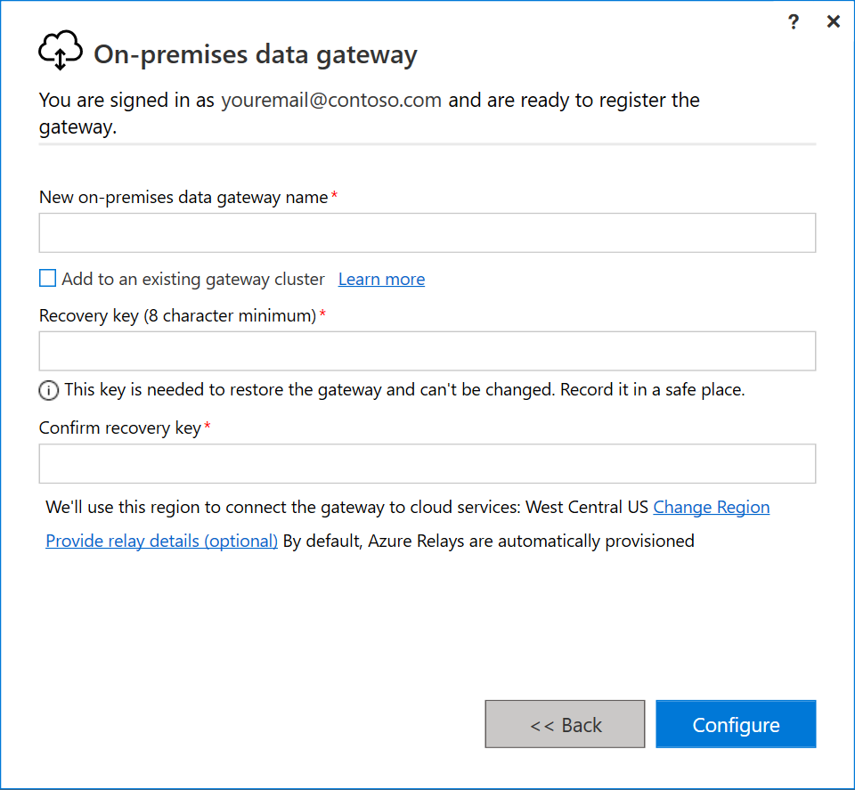
- Review the information in the final window. Because this example uses the same account for Power BI, Power Apps, and Power Automate, the gateway is available for all three services. Select Close.
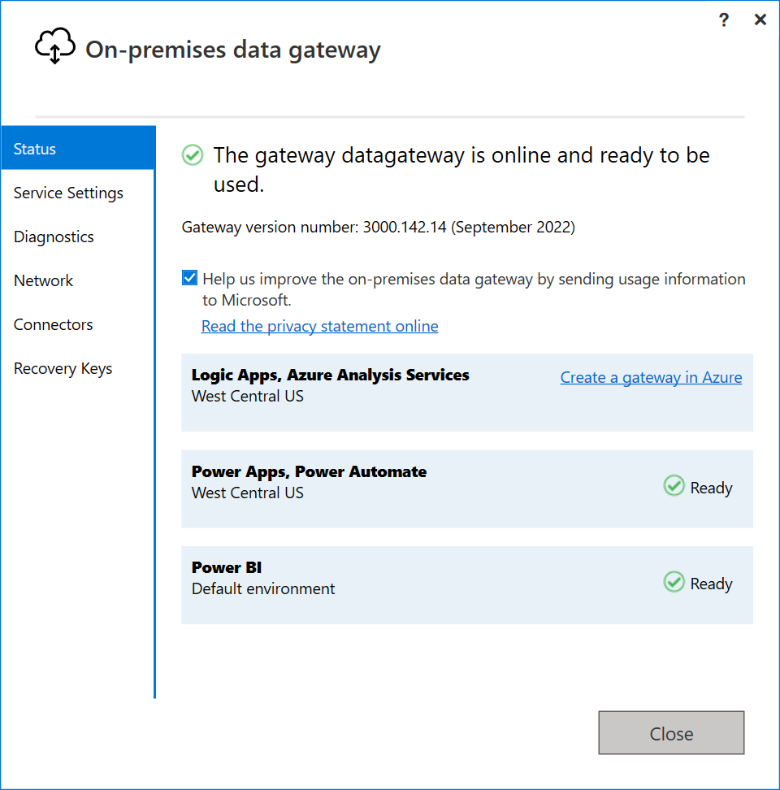
Now that you've installed a gateway, you can add another gateway to create a cluster.

